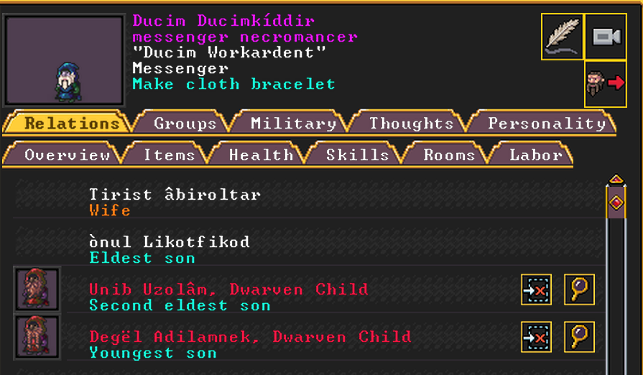
Ducim Workardent, former master of Mafol, has 2 young kids, and 1 very old one (?)
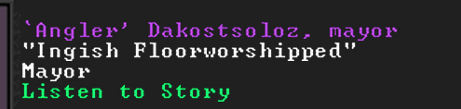
Ingish Floorworshipped - The mayor, has 2 kids, husband is detective guy
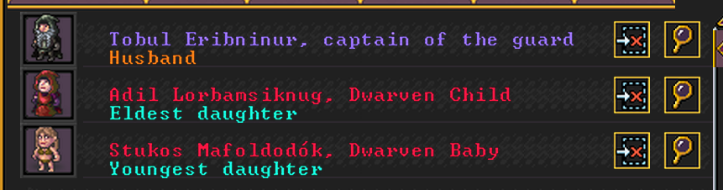

Avuz Dragonboard – apprentice of Mafol
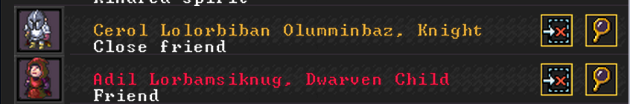
Cerol Letterballs– third seat of the Knights of Stars, Mafol considers him a close friend - but he thinks of her as barely an acquittance, friends with the Mayor
Adil Standarddwellings– daughter of the Mayor, Mafol thinks she is a cool kid

Zon Paddlesoothes - the third necromancer, no idea what his deal is

Accomplice in the mug theft, punished lightly


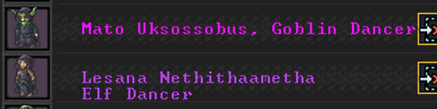
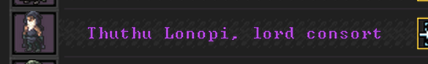
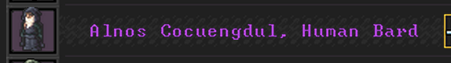



Glitched citizens?



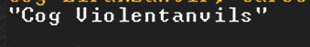
The cursed in the caverns

The lady in the wall

